These are the major changes made in Usama’s Code compared with Ibrahim’s Code:

* base_generic.html changed to base.html
* “match” folder changed to “matchDetails” in template dir
* Changes to match/details.html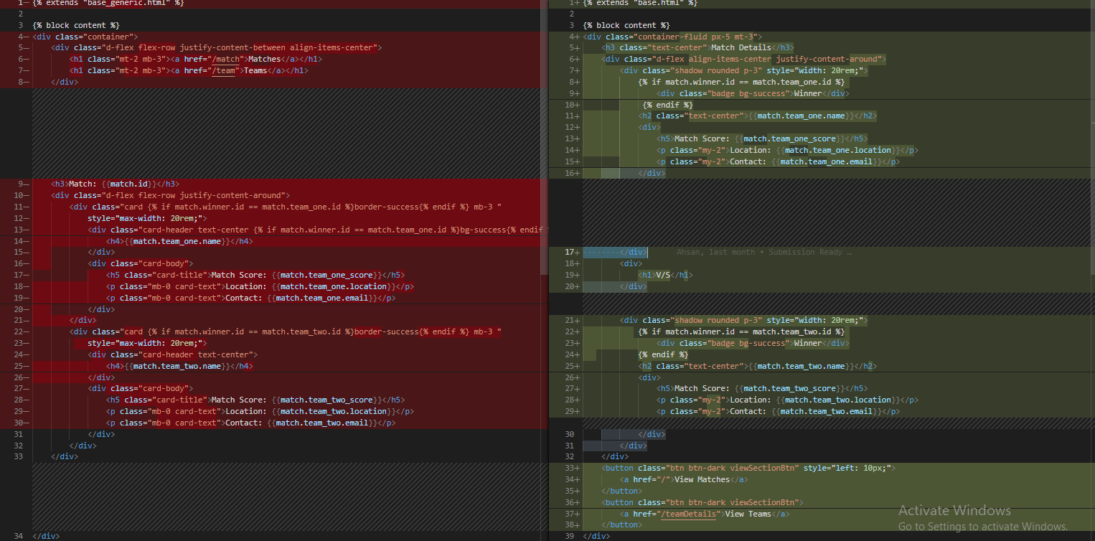
* Changes made to match/index.html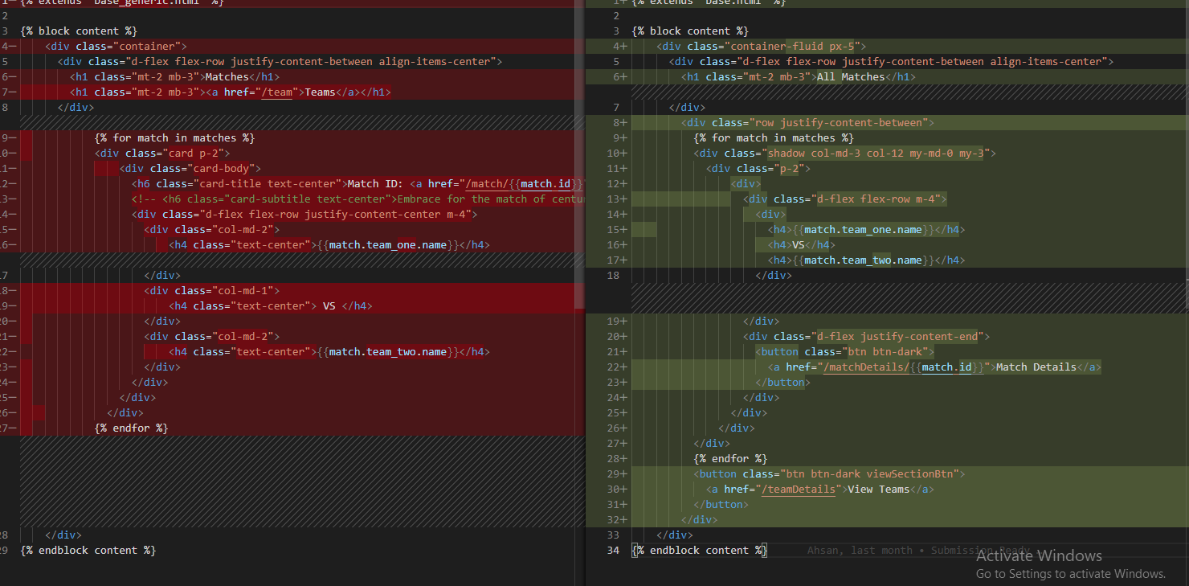
* “team” folder changed to “teamDetails” in template dir
* Changes made to team/index.html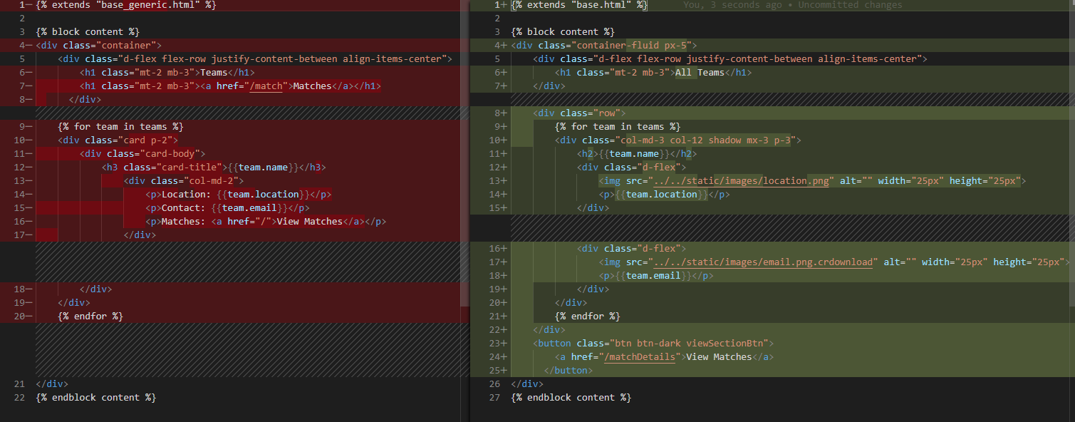
* Changes made to team/view.py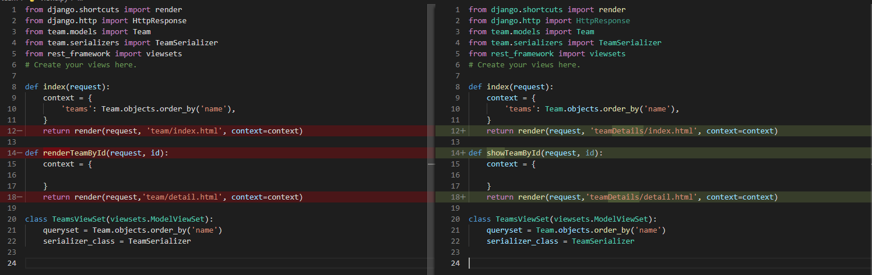
* Changes made to application/urls.py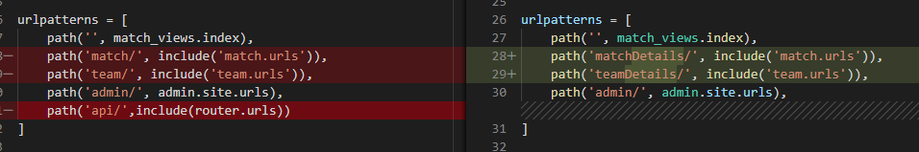
* Changes made to match/views.py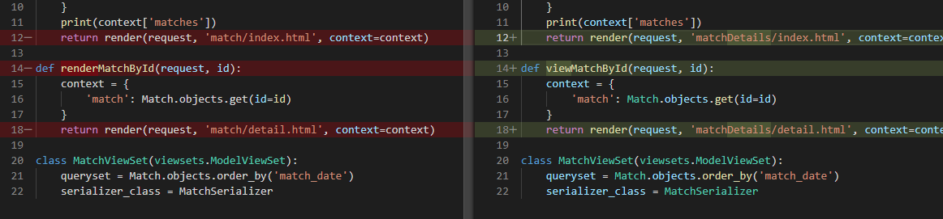
* Changes made to global.css